Jordan Evangelical Theological Seminary Chapel Dr. Rick Griffith
Title
4 Nov 2021 Message 2 of 4
NLT 30 Minutes
The Inheritance of the Believer: Part 2
Our Salvation is Secure but Defectors Lose Rewards
NT Summary of the Partakers View

Topic: Apostasy
Subject: How can we hold both assurance and apostasy?
Complement: Our salvation is secure but defectors lose rewards.
Purpose: The listeners will commit themselves to be faithful and fully rewarded before Jesus.

Introduction

Interest: Will each genuine Christian persevere in faithfulness at death?
Persevere?

We are talking ONLY about TRUE Christians here—not those who THINK they are believers but are not.

We all still struggle with sin after trusting Christ, but this question asks if every REAL Christian will continue to walk with Christ to the extent that he or she will die believing.

Or can that genuine believer deny Jesus during his or her life and die in that state of disbelief?

Turn to your neighbor and answer YES, NO, or DON’T KNOW.

Need: This is not an irrelevant, simply theological, question.

We all know people we thought believed in Jesus but no longer do so—and some are very close to us. In essence, they are “believers who no longer believe.”

God wants us to have both eternal security and assurance of salvation (distinguish them).
Terms
(2 slides)

Sadly, some believers have eternal security but are not taught correctly so they do not know assurance of salvation.

There are even others who falsely think they have assurance when in fact, they are not saved and thus do not have eternal security!

Subject: [How can we hold both assurance and apostasy?]

Essentially three views are possible to answer the perseverance question (review flow chart).
Flow Chart
(animate)

Another way to look at this is to see it as three views on apostasy (review circles diagram).
Circles
(animate)

The Partakers View is the newest, but I believe it is the most faithful to the Bible. It also has the strengths of the other views while avoiding their weaknesses, thus advocating a mediating view.

Here is our question to answer today: How can we hold both assurance and apostasy?
• Subject

Background: JETS teaches both salvation by faith and assurance of salvation.
How both
A & A?
JETS
(2 slides)

Preview: Today we will see three arguments for the Partakers View that supports both assurance and apostasy.

(How can we hold both assurance and apostasy? What is the first support for the Partakers View?)

I. The Bible distinguishes our two inheritances.
• MP
[Both the OT and NT teach that we can be heirs in two ways.]
Inheritance
(3 slides)

Inheritance in the NT—like the OT—is of two types (Romans 8:17).
Rom 8:17
• Saved

All Christians are heirs of God.
Rom 8:17
• Reward

Believers sharing in his suffering are co-heirs with Christ.
Kingdom Chart

The NT distinguishes entering and inheriting the kingdom.

All Christians enter the kingdom for salvation but not for discipleship.
Enter/Heir
(3 slides)

Faithful believers inherit the kingdom.
Crowns
(3 slides)

Only faithful believers will receive crowns (James 1:12, etc.).

(How can we hold both assurance and apostasy? What is the second support for the Partakers View?)

II. Only overcomers will reign with Christ.
MP
[The privilege to rule with Jesus is reserved for the faithful.]
Overcomer
(17 slides)

Jesus will reward for every faithful believer in each of the seven churches (Rev 2–3; 21:8).
Ready Rule
(7 slides)

Other NT texts promise that faithful saints will rule (Rev 20:4; 1 Cor 6:2; 2 Tim 2:12).

(How can we hold both assurance and apostasy? What is the third support for the Partakers View?)
MP

III. Believers abandoning Jesus lose rewards and rule.
[Apostates will be saved but not rewarded, nor reign with Christ.]
Acts 5
(2 slides)

Ananias and Sapphira were believers whose sin led to death (Acts 5).
Bema
(8 slides)

The bema (judgment seat) of Christ will reward only good works (1 Cor 3:12-15).
1 Cor 9

Believers can be disqualified (1 Cor 9:24-27).
2 John 8
Rev 3:11
1 Cor 11
(2 slides)

Christ promises rewards for perseverance (Rev. 3:11b).

Rewards can be lost (2 John 8).

Some Corinthians had died from sin (1 Cor 11:27-32).
1 John 5:16-17

Some sin leads to premature death (1 John 5:16-17).

(How can we hold both assurance and apostasy?)

Conclusion
MP

Main Points

The Bible distinguishes our two inheritances.

Only overcomers will reign with Christ.

Believers abandoning Jesus lose rewards and rule.
MI

Our salvation is secure but defectors lose rewards (Main Idea).

The Bible teaches both assurance and apostasy—so believers can lose rewards but not salvation (MI restated).

Summary
Clothed

All believers are clothed with Christ’s righteousness.
Heaven

All believers will enjoy heaven.
Jesus will Judge
Jesus will Reward

But Jesus will judge the earth.

Jesus will reward the faithful.

Exhortation: Live towards your future!
Turning = Forfeit Rule
Future!

Turning away from Christ forfeits your future rule.

Prayer
Prayer

Preliminary Questions

Verses Questions

Context: What did the author record just prior to this passage?

My first message in this 4-part series affirmed that salvation is by faith but rewards are by works.

In relation to this, the OT teaches two types of inheritance for the believer: salvation and reward.

Purpose: Why is this passage in the Bible?

Being able to distinguish between salvation and reward will help us understand many NT texts as well.

It will also help us see that both the Reformed and Arminian views on apostasy teach scriptural truth.

But actually, believers hold one of three basic views on eternal security, perseverance, and rewards.

But what support is there in the Bible for the Partakers View?

Background: What historical context helps us understand this passage?

We all have likely either come from a Reformed or Arminian position.

JETS seeks to represent the Bible rather than any denomination.

Questions

Does JETS teach the Reformed or Arminian position? Neither.

Does JETS teach assurance of salvation? Yes.

Why does the great majority of the church feel pressured to hold either the Reformed and Arminian view? Why not a mediating view?

Tentative Subject/Complement Statements

Our salvation is secure but defectors lose rewards (Main Idea).

The Bible teaches both assurance and apostasy—so believers can lose rewards but not salvation (MI restated).

Possible Illustrations

Flow chart

Circles

Possible Applications

Pray for those you are not sure know Christ.

When in doubt, witness!

The Inheritance of the Believer: Part 2
Our Salvation is Secure but Defectors Lose Rewards
NT Summary of the Partakers View

Purpose or Desired Listener Response (Step 4)
The listeners will commit themselves to be faithful and fully rewarded before Jesus.

Homiletical Outline (Cyclical inductive form)

Introduction

Interest: Will each genuine Christian persevere in faithfulness at death?

Need: This is not an irrelevant, simply theological, question.

Subject: [How can we hold both assurance and apostasy?]

Background: JETS teaches both salvation by faith and assurance of salvation.

Preview: Today we will see three arguments for the Partakers View that supports both assurance and apostasy.

(How can we hold both assurance and apostasy? What is the first support for the Partakers View?)

I. The Bible distinguishes our two inheritances.

Inheritance in the NT—like the OT—is of two types (Romans 8:17).

All Christians are heirs of God.

Believers sharing in his suffering are co-heirs with Christ.

The NT distinguishes entering and inheriting the kingdom.

All Christians enter the kingdom.

Faithful believers inherit the kingdom.

Only faithful believers will receive crowns (James 1:12, etc.).

II. Only overcomers will reign with Christ.

Jesus will reward for every faithful believer in each of the seven churches (Rev 2–3; 21:8).

Other NT texts promise that faithful saints will rule (Rev 20:4; 1 Cor 6:2; 2 Tim 2:12).

III. Believers abandoning Jesus lose rewards and rule.

Ananias and Sapphira were believers whose sin led to death (Acts 5).

The bema (judgment seat) of Christ will reward only good works (1 Cor 3:12-15).

Believers can be disqualified (1 Cor 9:24-27).

Christ promises rewards for perseverance (Rev. 3:11b).

Rewards can be lost (2 John 8).

Some Corinthians had died from sin (1 Cor 11:27-32).

Some sin leads to premature death (1 John 5:16-17).

(How can we hold both assurance and apostasy?)

Conclusion

Our salvation is secure but defectors lose rewards (Main Idea).

The Bible teaches both assurance and apostasy—so believers can lose rewards but not salvation (MI restated).

Main Points

Summary

Exhortation: Live towards your future!

Turning away from Christ forfeits your future rule.

Prayer

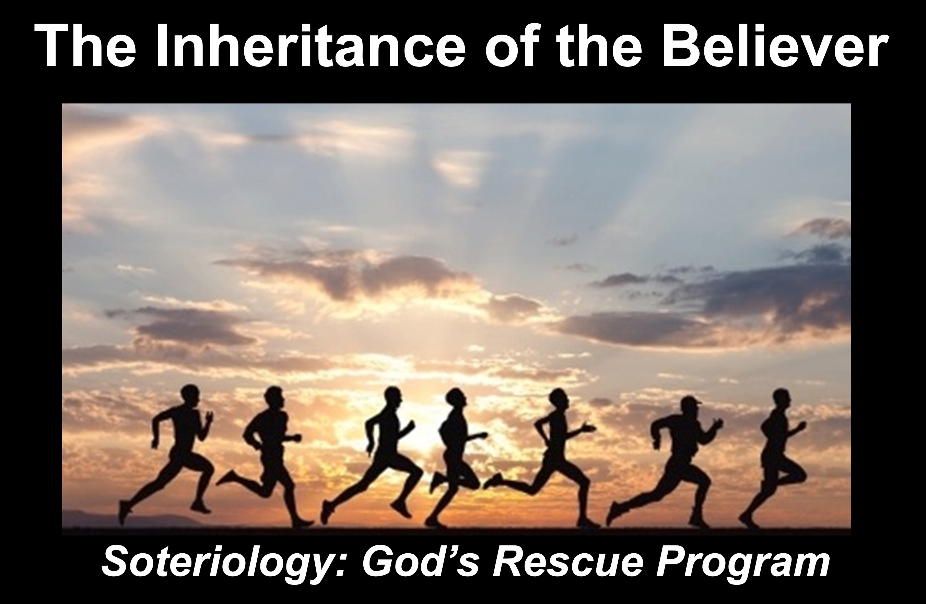
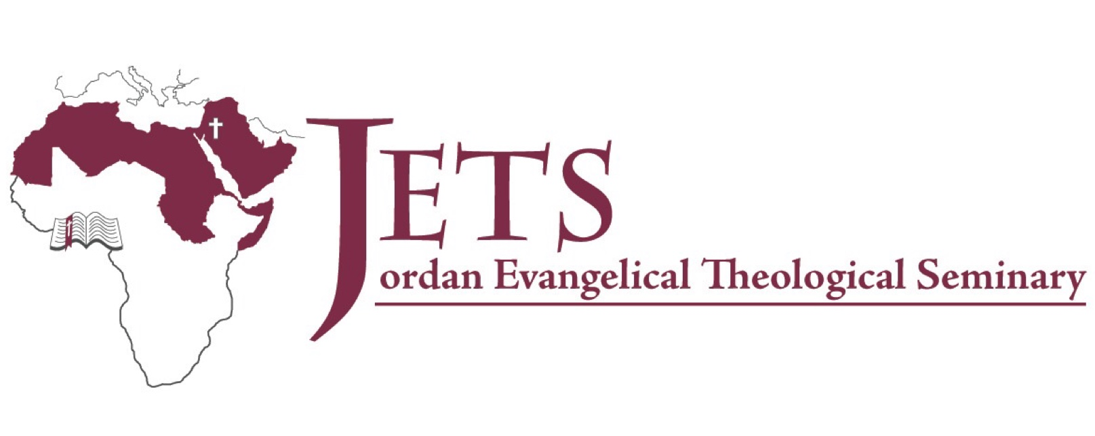
Rick Griffith
4 Nov 2021
Message 2 of 4

The Inheritance of the Believer: Part 2
Our Salvation is Secure but Defectors Lose Rewards
NT Summary of the Partakers View

Introduction

Will each genuine Christian persevere in faithfulness at death?

How can we hold both assurance and apostasy?

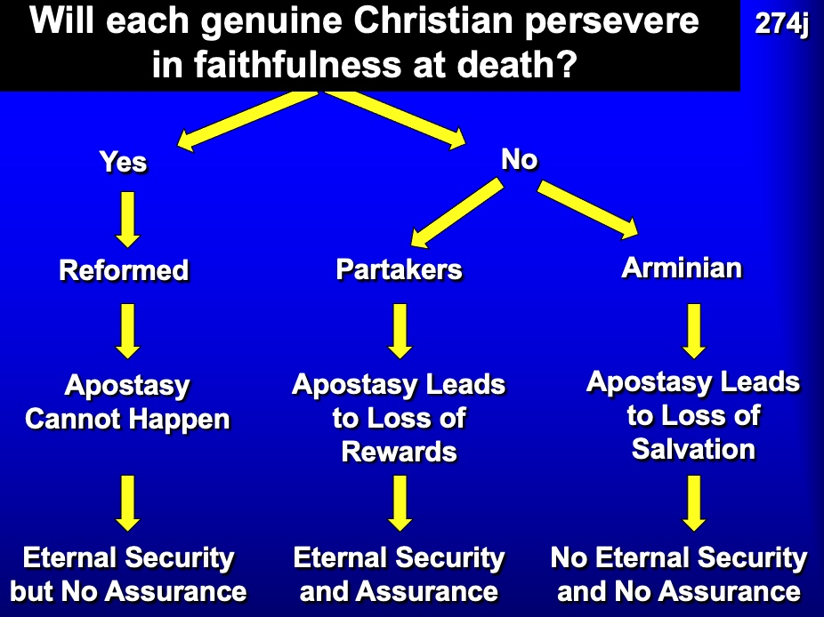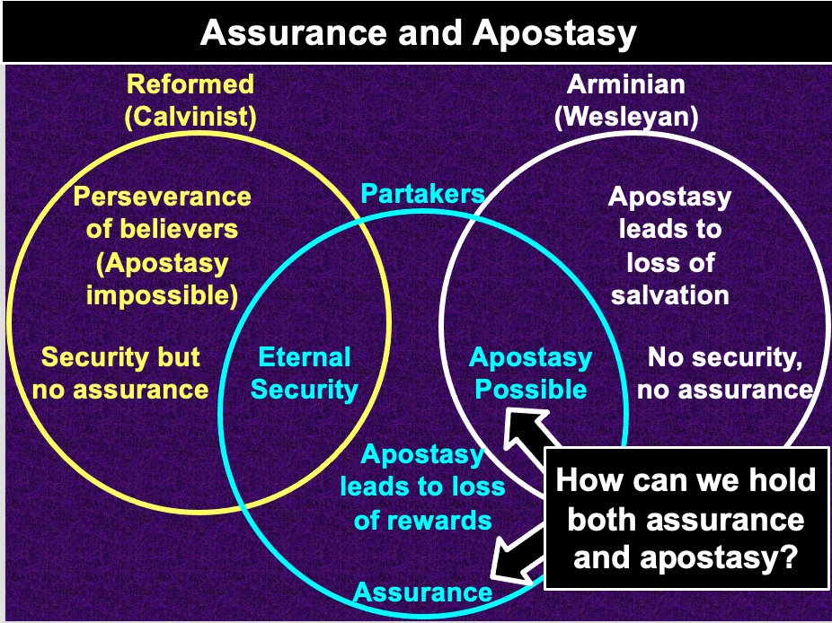

JETS teaches both salvation by faith and assurance of salvation.

Today we will see three arguments for the Partakers View that supports both assurance and apostasy.

(How can we hold both assurance and apostasy? What is the first support for the Partakers View?)

I. The Bible distinguishes our two inheritances.

Inheritance in the NT—like the OT—is of two types (Romans 8:17).

All Christians are heirs of God.

Believers sharing in his suffering are co-heirs with Christ.

The NT distinguishes entering and inheriting the kingdom.

All Christians enter the kingdom.

Faithful believers inherit the kingdom.

Only faithful believers will receive crowns (James 1:12, etc.).

II. Only overcomers will reign with Christ.

Jesus will reward for every faithful believer in each of the seven churches (Rev 2–3; 21:8).

Other NT texts promise that faithful saints will rule (Rev 20:4; 1 Cor 6:2; 2 Tim 2:12).

III. Believers abandoning Jesus lose rewards and rule.

Ananias and Sapphira were believers whose sin led to death (Acts 5).

The bema (judgment seat) of Christ will reward only good works (1 Cor 3:12-15).

Believers can be disqualified (1 Cor 9:24-27).

Christ promises rewards for perseverance (Rev. 3:11b).

Rewards can be lost (2 John 8).

Some Corinthians had died from sin (1 Cor 11:27-32).

Some sin leads to premature death (1 John 5:16-17).

(How can we hold both assurance and apostasy?)

Conclusion

Our salvation is secure but defectors lose rewards (Main Idea).

Live towards your future!

Turning away from Christ forfeits your future rule.

Download this sermon PPT and notes for free at BibleStudyDownloads.org/resource/new-testament-preaching/

